**college admission management**

**Submitted to**

**SAVEETHA INSTITUTE OF MEDICAL AND TECHNICAL SCIENCES**

**In partial fulfillment for the completion of the**

**Manoj.B**

**Cse**

**192110403**

UNDER THE GUIDANCE OF;

k.vijaya bhaskar

Assistant professor**.**



**INSTITUTE of SCience and HUMANITIES**

**SAVEETHA SCHOOL OF ENGINEERING**

**CHENNAI – 602 105**

**TAMILNADU, INDIA**

**September 2022**

**BONAFIDE CERTIFICATE**

**Certified that this project report “ ETHICS AND MARKETING” is the bonafide work of A.Abhi Ram Reddy, 192011018 cse.)” who carried out the project work under my supervision.**

**SIGNATURE SIGNATURE**

k.vijaya bhaskar

**HEAD OF THE DEPARTMENT, Assistant professor,**

Professor and Head, Department of CSE, **Department of CSE,**

Saveetha School of Engineering, Saveetha School of Engineering,

Saveetha University . Saveetha University.

**INTERNAL EXAMINER EXTERNAL EXAMINER**

**DECLARATION BY THE CANDIDATE**

I declare that the report entitled **“college admission management”** submitted by me for the degree of Electronics and communication engineering is the record of the project work carried out by me under the guidance of **“**k.vijaya bhaskar**”** and furthermore this work has not formed the basis for the award of any degree or diploma in this or any other University or other similar institution of higher learning.

**Manoj.B**

**Cse**

**192110403**

**ACKNOWLEDGEMENT**

**This project work would not have been possible without the contribution of many people. It gives me immense pleasure to express my profound gratitude to our honorable Chancellor Dr.N.M. VEERAIYAN, Saveetha Institute of Medical and Technical Sciences, for his blessings and for being a source of inspiration. I sincerely thank our Vice Chancellor Dr. Rakesh Kumar Sharma for his visionary thoughts and support. I am indebted to extend my gratitude to our Director madam Mrs. Ramya Deepak, Saveetha School of Engineering, for facilitating us all the facilities and extended support to gain valuable education and learning experience.**

**I register my special thanks to Dr. B. RAMESH, Principal, Saveetha School of Engineering and Dr. KRUBA GANAPATHY, HOD, Department of Electronics and communication Engineering, for the support given to me in the successful conduct of this project. I wish to express my sincere gratitude to my supervisor k.vijaya bhaskar., for his inspiring guidance, personal involvement and constant encouragement during the entire course of this work.**

**I am grateful to Project Coordinators, Review Panel External and Internal Members and the entire faculty of the Department of ECE for their constructive criticisms and valuable suggestions which have been a rich source to improve the quality of this work.**

Tittle: college admission management

Introduction:

The admission management system is software that enables educational institutions to conduct student admission and enrollment procedures online.

The admission management system manages student admission form collection, collects documents, and shortlists candidates to complete the admission process online.

The admission management system is a digital tool that helps educational institutions manage the student enrollment process effortlessly.

It lets admission teams capture student inquiries, check their eligibility, follow-up, collect documents, and complete the application process digitally.

The admission management system also allows students to cv apply online, check their application status, submit documents and pay fees online.

The admission management system is a digital tool that helps educational institutions manage the student enrollment process effortlessly.

>It lets admission teams capture student inquiries, check their eligibility, follow-up, collect documents, and complete the application process digitally.

>The admission management system also allows students to apply online, check their application status, submit documents and pay fees online.

ABSTRACT:

College Admission Management System is a web-based application in which students can register and it manages all the student records.

=> It is an online system that can be accessed throughout the organization.

=>This system stores the list of students along with the relevant information.

=>With this system the total time for the entrance allotment became lesser and the admission process became faster.

=>College Admission Management System helps to make the admission process much easier and helps in maintaining the database in efficient way.

=>Needless to say that the admission cycle is long and cumbersome.

=> From student lead generation, document collection, selection,and admissions everything involves a lot of paperwork.

Objectives:

***Online Admission System*** is aimed at developing an online admission application for a college. This system is an online system that can be accessed throughout the organization and outside as well with proper login provided. Our system has two type of accessing modes, administrator and user. Student management system is managed by an administrator. It is the job of the administrator to admit  and monitor the whole process. When a user log in to the system. He would only view details of the student. He can't perform any changes .The system has two modules. They are

* User
* Administrator
* Students logging is to apply for the course by filling an application form provided by online. College principal/administrator logging in may also access/search information put up by the students.

Literature survey:

1. A Research Paper on College Management System.- Lalit Mohan Joshi, International Journal of Computer Applications ,Volume 122 No.11, July 2015
2. Web Based Student Information Management System- S.R. Bharamagoudar1, Geeta R.B.2, S.G.Totad, International Journal of Advanced Research in Computer and Communication Engineering Vol. 2, Issue 6, June 2013
3. Advanced Embedded System Assisted Gsm and Rfid Based Smart school Management System.V. Sivasankaran, S.Muruganand, Azha. Periasamy international Journal of Advanced Research in Electrical, Electronics And Instrumentation Engineering Vol. 2, Issue 7, July 2013.
4. N. M. Z. Hashim and S. N. K. S. Mohamed, Development of Student Information System University Teknikal Malaysia Melaka, vol. 2, pp. 256 – 260, August 2013.
5. An Efficient Automatic Attendance System Using Fingerprint Reconstruction Technique. Josphineleela.R Research Scholar Department Of Computer Science And Engineering

Advantages:

The objective of online college admission system is to reduce the manual work and excess time taken for admission process. Student can login into the system by signing up. They can fill the form of admission

,revaluation, and photocopy. Also the details regarding the updated information of their admission is displayed on the window. The online college admission system ease the admission process by maintaining the database and retrieving the information of student easily. This system aims at being efficient and user-friendly.

IMPLEMENTATION

The Online College Admission System consists of three Modules such as User, Server and Admin.

A. USER

The student who wants to seek admission is the user of the online system. The student registers himself/herself with the system and becomes authenticated user after the login process. The students can seek admission in 2nd,3rd and 4th year of engineering college as per their academic year. The admission form is filled by the student after logging in the system and the documents such as previous years mark sheets, aadhar card, caste certificates, etc. are scanned and uploaded in the system. The application forms for provisional admission, photocopy and revaluation can be filled the user in the similar fashion. All these details can be accessed by the admin via server. If the admin verifies the form and grants permission to the user for admission, a message will be generated and sent to the student ID through server.If an unauthenticated user tries to login in the system, he/she is not permitted to do so

B. SERVER

The Server acts as a medium between the authenticated user (student) and the admin. All the details entered and documents uploaded by the student is stored in the server (Wamp Server).The admin can access these details via server. When the admin verifies the student details and grants permission for regular admission/provisional admission/photocopy/revaluation process, a message will be generated to the user sent by admin via server.

C. ADMIN

The admin plays a pivotal role in the online admission system. It is the admin who provides authentication to the user in the online process. The details entered and the documents uploaded by the authenticated user is accessed by the admin via server.

Methodology:

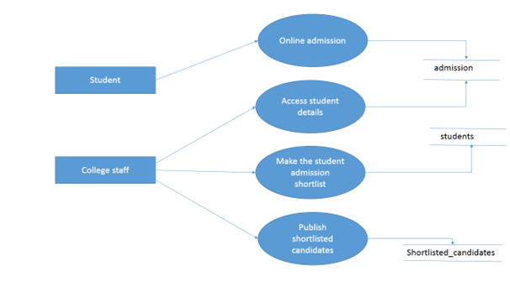

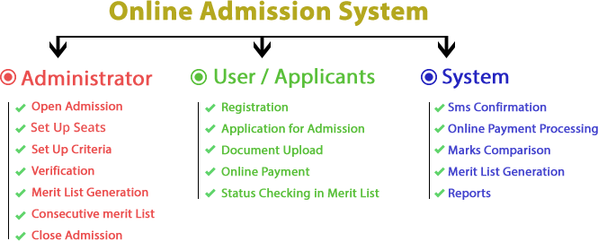

Finding:

*For the google survey the total number of responses we got 5

*It is about the college admission management system

*the responses we got for the dept

1. B . Teach in computer science -80%

1. B. Teach in computer techonology -90%
2. B.sc . in AI&ML -0%
3. CIVIL-0%

Data analytics

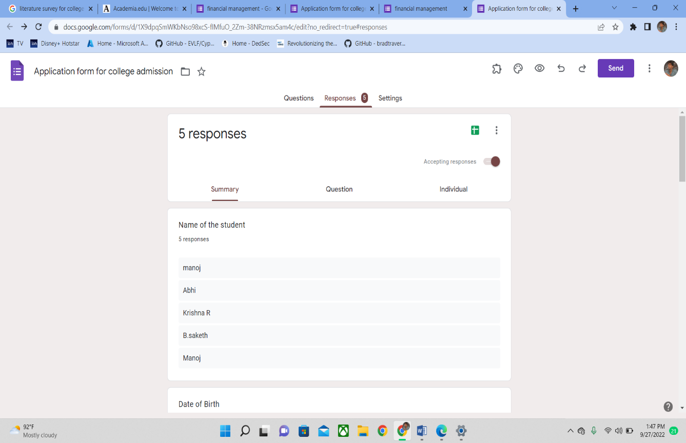

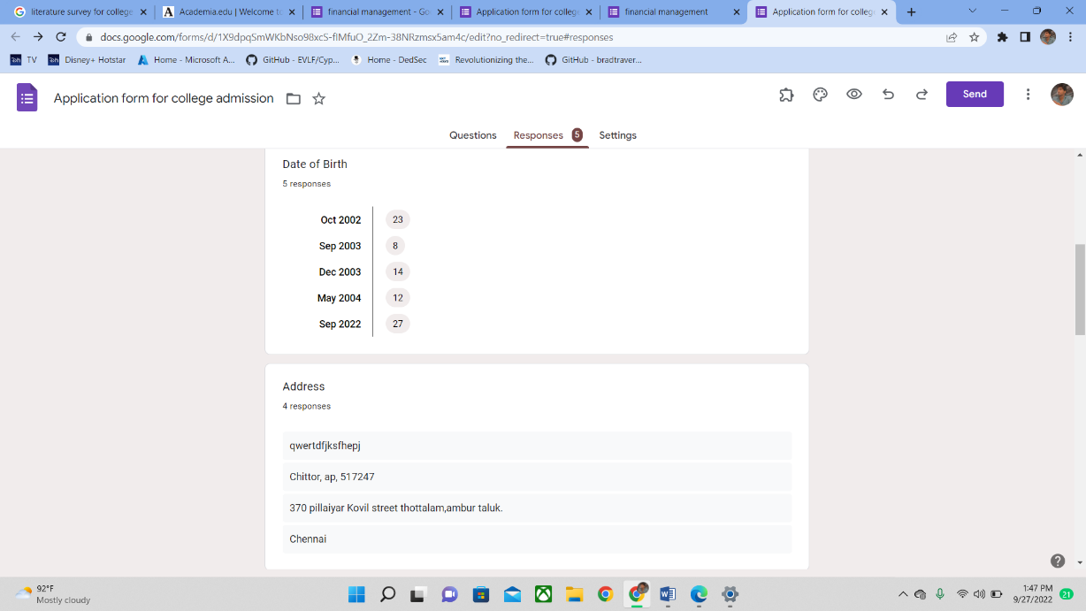

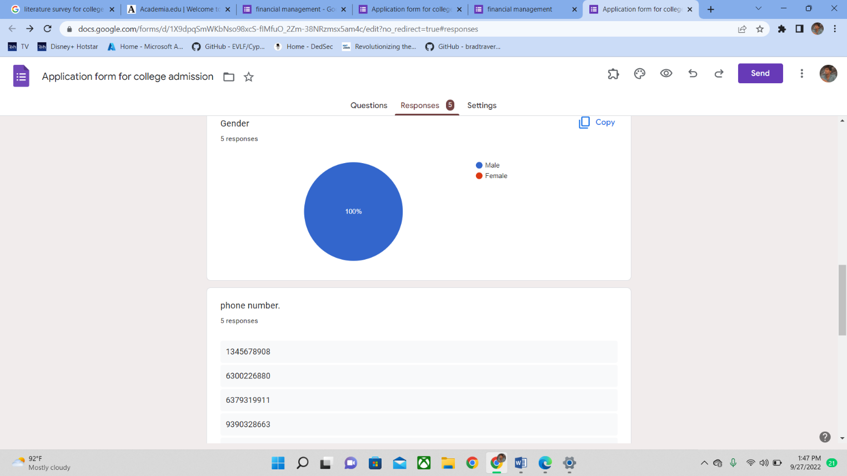 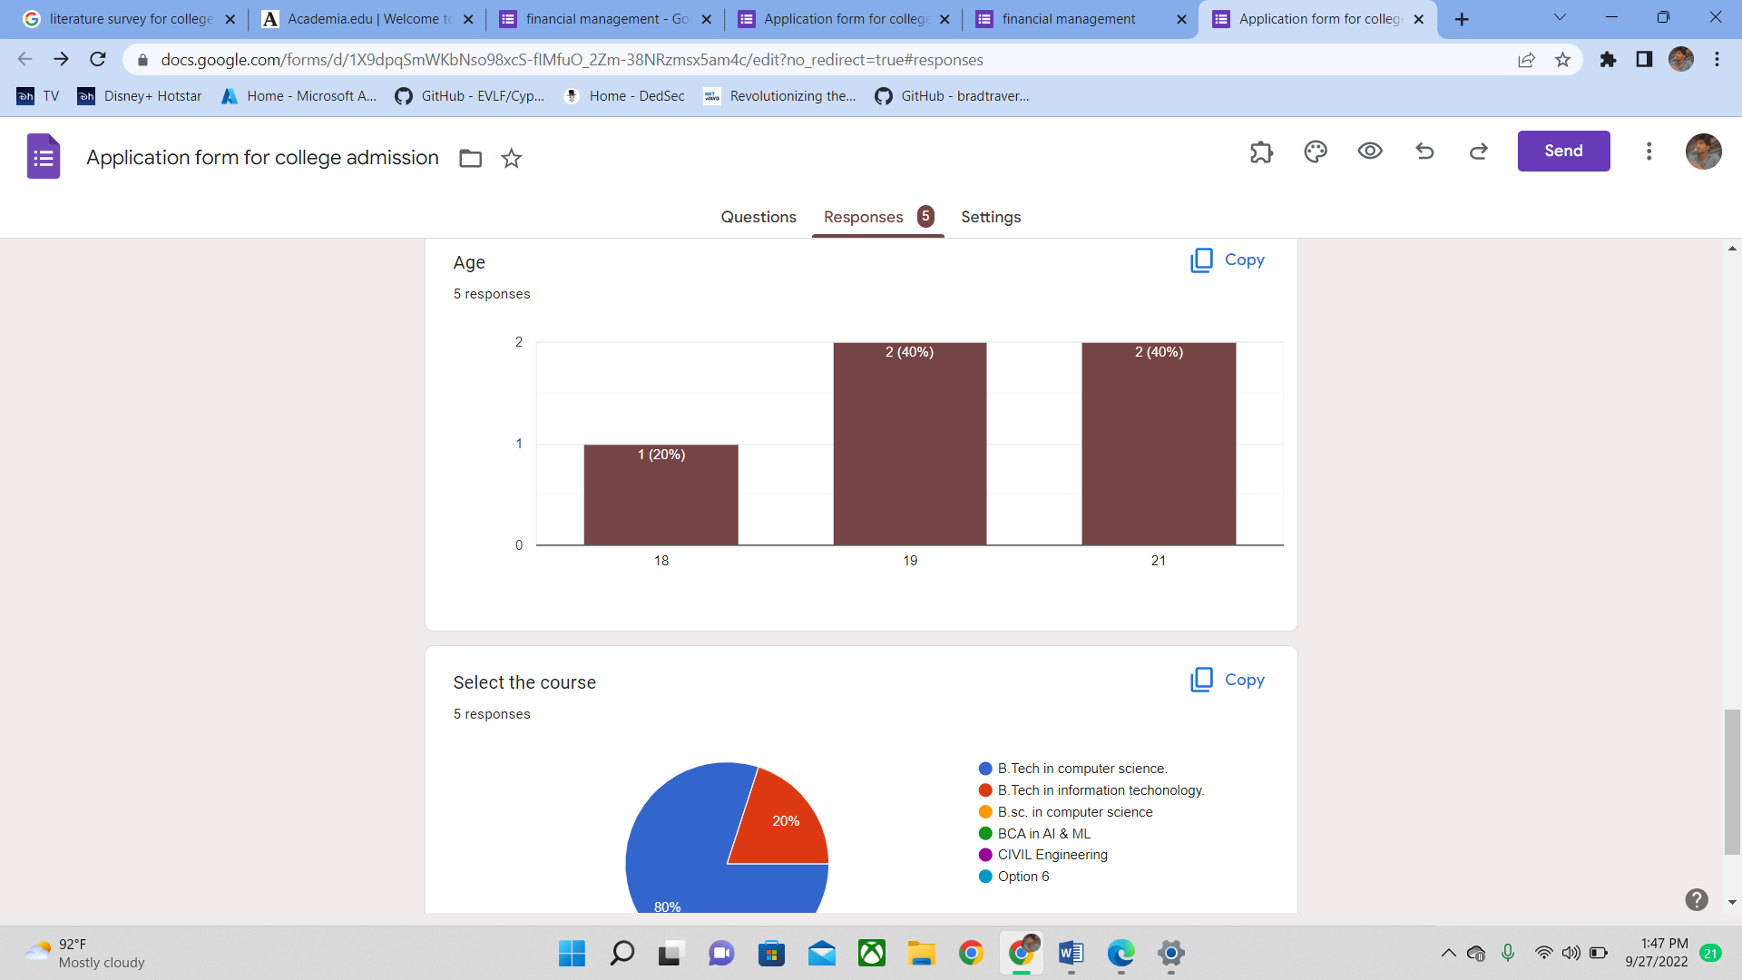

Model testing:

During this phase a second set of data is loaded. This data set has never been seen by the model and therefore it’s true accuracy will be verified. After the model training is complete, and it is understood that the model shows the right result, it can be saved by: model.save(“name_of_file.h5”). Finally, the saved model can be used in the real world. The name of this phase is model evaluation. This means that the model can be used to evaluate new data.

.

CONCLUSIONS:

In this way we are going to develop onlin college admission system , which minimize the time required for the manual admission process system. Records of the students can be produced easily in a short span of time. Workflow of the process will lead to efficiency and will be user friendly.

References:

1)N. M. Z. Hashim and S. N. K. S. Mohamed, Development of Student Information System University Teknikal Malaysia Melaka, vol. 2, pp. 256 – 260, August 2013.

2)An Efficient Automatic Attendance System Using Fingerprint Reconstruction Technique. Josphineleela.R Research Scholar Department Of Computer Science And Engineering

3.A Research Paper on College Management System.- Lalit Mohan Joshi, International Journal of Computer Applications ,Volume 122 No.11, July 2015

4.Web Based Student Information Management System- S.R. Bharamagoudar1, Geeta R.B.2, S.G.Totad, International Journal of Advanced Research in Computer and Communication Engineering Vol. 2, Issue 6, June 2013

5.Advanced Embedded System Assisted Gsm and Rfid Based Smart school Management System.V. Sivasankaran, S.Muruganand, Azha. Periasamy international Journal of Advanced Research in Electrical, Electronics And Instrumentation Engineering Vol. 2, Issue 7, July 2013